

**Tribhuvan University**

**Faculty of Humanities and Social Science**

**ONLINE ROOM RESERVATION SYSTEM**

**A PROJECT REPORT**

**Submitted to:**

**Department of Computer Application**

**Prime College**

***In partial fulfillment of requirements in Bachelor in Computer***

***Applications***

Submitted by:

Dev Tshering Lama

Sudhesh Shrestha

June, 2023 A.D.

**Under the Supervision of**

**Mr. Deepak Dahal**



**Tribhuvan University**

**Faculty of Humanities and Social Science**

**Prime College**

# Supervisor’s Recommendation

I hereby recommend that this project prepared under my supervision by Sudhesh Shrestha and Dev Tshering Lama entitled **“Homelystay - Online Room Reservation System”** in partial fulfillment of the requirements for the degree of Bachelor of Computer Application is recommended for the final evaluation

Mr. Deepak Dahal

SUPERVISOR

Lecturer, Department of IT

Prime College



**Tribhuvan University**

**Faculty of Humanities and Social Science**

**Prime College**

# LETTER OF APPROVAL

This is to certify that this project prepared by Sudhesh Shrestha and Dev Tshering Lama entitled **“Homelystay - Online Room Reservation System”** in partial fulfillment of the requirements for the degree of Bachelor in Computer Application has been evaluated. In our opinion it is satisfactory in the scope and quality as a project for the required degree.

|  |  |
| --- | --- |
| **Mr. Deepak Dahal**  **Supervisor**  **Prime College**  **Khusibu, Nayabazar, Kathmandu** | **Ms. Rolisha Sthapit**  **BCA Co-Ordinator**  **Prime College**  **Khusibu, Nayabazar, Kathmandu** |
|  | **Prof.**  **External Examiner** |

# ABSTRACT

The Online Room Reservation System is an innovative web-based platform designed to simplify and enhance the process of room bookings for both customers and hotel management. This system makes use of technology to deliver seamless and effective reservation experiences, guaranteeing everyone's convenience, accuracy, and flexibility. The system is built with HTML and JavaScript on the front end, PHP on the back end, and MySQL for database storage.

By completing the registration form and logging in with their registered username and password, users can access the system. Users can browse through a large database of rooms and view detailed information about each room and pricing using the system's user-friendly interface. Customers can easily search for rooms based on their preferences, such as budget constraints. Customers can make reservations at the hotel by selecting a specific room, indicating the number of visitors, and supplying personal information.

The system provides a complete set of tools and capabilities for hotel management to effectively handle reservations, availability, and price. Admin can quickly update the number of rooms available, change pricing and more information.

Overall, the Online Room Reservation System revolutionizes the hotel booking process by providing a user-friendly interface, secure transactions, and efficient management tools.

*Keywords: Technology, Room, Users, Preference, HTML, PHP, MySQL*

# ACKNOWLEDGEMENT

We would like to convey our sincere gratitude to everyone who has assisted us in developing this project for the partial completion of the project in BCA 4th Semester. There were times when we believed this project was too difficult or impossible to accomplish, but I am grateful to my supervisor, Mr. Deepak Dahal, who constantly encouraged us to give it our all and finish it. Similarly, we are grateful to our organizer, Ms. Rolisha Sthapit, for her assistance with our initiative.

It would be very difficult this project without the assistance of our instructor Kamana Ghimire, who has guided us throughout and assisted us in understanding and correcting our mistakes. We'd also like to acknowledge my classmates' unwavering support, which encouraged us to keep working on the project and reminded us about the competition on a regular basis in a kind manner. We also received assistance from Prime College seniors, and we would want to express our gratitude to them from the bottom of our hearts. We were able to successfully accomplish this project due of all of you.

Finally, we'd like to express our gratitude to Tribhuvan University for providing us with this chance through the Computer Application course to assist us comprehend project ethics at an early level and to evaluate and expand our knowledge.

**TABLE OF CONTENTS**

**SUPERVISOR’S RECOMMENDATION.................................................................... 1**

**LETTER OF APPROVAL............................................................................................... 2**

**ABSTRACT ........................................................................................................................ 3**

**ACKNOWLEDGEMENT ................................................................................................ 4**

**TABLE OF CONTENT ................................................................................................... 5**

**LIST OF ABBREVIATION............................................................................................. 7**

**LIST OF FIGURES........................................................................................................... 8**

**LIST OF TABLES ............................................................................................................ 9**

**CHAPTER 1 INTRODUCTION...................................................................................... 10**

1.1 Introduction .......................................................................................................... 10

1.2 Problem Statement ................................................................................................ 11

1.3 Objectives ..............................................................................................................11

1.4 Scope and Limitation............................................................................................ 12

1.5 Development Methodologies................................................................................ 12

1.6 Report Organization .............................................................................................. 15

**CHAPTER 2 BACKGROUND STUDY AND LITERATURE REVIEW ................... 16**

2.1 Background Study ................................................................................................. 16

2.2 Literature Review.................................................................................................. 17

**CHAPTER 3 SYSTEM ANALYSIS AND DESIGN ...................................................... 19**

3.1 System Analysis ....................................................................................................19

3.1.1 Requirement Analysis ....................................................................................19

3.1.2 Feasibility Study ............................................................................................22

3.1.3 Data Modeling .............................................................................................25

3.1.4 Process Modeling .........................................................................................26

3.2 System Design .....................................................................................................28

3.2.1 Architectural Design ....................................................................................28

3.2.2 Database Schema Design .............................................................................29

3.2.3 Interface Design ...........................................................................................30

3.2.4 Physical DFD ...............................................................................................32

**CHAPTER 4 IMPLEMENTATION AND TESTING ................................................. 33**

4.1 Implementation....................................................................................................33

4.1.1 Tools Used (CASE Tools, Programming Language, Database Platforms) 33

4.1.2 Implementation Details and Modules .......................................................... 34

4.2 Testing................................................................................................................. 34

4.2.1 Test case design for unit testing ..............................................................35

4.2.2 Test case design for system testing........................................................ 39

4.2.3 Test case execution for system testing…………………………………41

**CHAPTER 5 CONCLUSION AND FUTURE RECOMMENDATIONS ..................44**

5.1 Lesson Learnt / Outcome .................................................................................... 44

5.2 Conclusion........................................................................................................... 44

5.3 Future Recommendation ..................................................................................... 45

**REFERENCES.................................................................................................................46**

**APPENDIX....................................................................................................................... 47**

# LIST OF ABBREVIATION

* **CSS:** Cascading Style Sheet
* **DFD:** Data Flow Diagram
* **ERD:** Entity Relationship Diagram
* **HTML:** Hypertext Markup Language
* **JS:** JavaScript
* **PHP:** Hypertext Preprocessor
* **SQL:** Structured Query Language

# LIST OF FIGURES

Figure 1.1: Waterfall Model Diagram ................................................................................. 13

Figure 3.1: Use Case Diagram ............................................................................................ 21

Figure 3.2: ER Diagram ...................................................................................................... 25

Figure 3.3: Context Level Data Flow Diagram. .................................................................. 26

Figure 3.4: Flowchart Diagram .............................................................................................27

Figure 3.5: Architectural Design ...........................................................................................28

Figure 3.6: Database Schema Design ................................................................................ 29

Figure 3.7: Interface Design .............................................................................................. 30

Figure 3.8: UI interface ...................................................................................................... 31

Figure 3.9: Physical DFD .................................................................................................. 32

# LIST OF TABLES

Table 3.1: Gantt Chart Table ........................................................................... 24

Table 4.2.1.1: Test Case execution for admin login.......................................... 35

Table 4.2.1.2: Test Case execution for user signup.......................................... 35

Table 4.2.1.3: Test Case execution for user login.............................................. 36

Table 4.2.1.4: Test Case execution for Room Booking...................................... 36

Table 4.2.1.5: Test Case execution for Room Addition...................................... 37

Table 4.2.1.6: Test Case execution for Staff Addition.........................................37

Table 4.2.2.1: Test case design for system testing................................................. 39

Table 4.2.3.1: Test case execution for system testing........................................... .41

# CHAPTER 1

# INTRODUCTION

* 1. **Introduction**

In today's fast-paced digital era, the travel and hospitality industry has witnessed a significant shift towards online platforms. The Online Room Reservation System serves as a virtual gateway that connects hotels with potential guests, offering a wide range of benefits and features. This system enables customers to explore numerous hotels, compare prices, view detailed information, and make reservations at their convenience, eliminating the need for time-consuming phone calls or visits to physical locations.

This project is a web-based application where users can access the system easily. The system maintains a database of rooms with detailed information, including room types, pricing, and availability. To book a room, the user must be registered as a new member, and after a successful login, he or she can book the rooms. Users can search and filter options based on their criteria, and once they select a room, they proceed with the booking process by providing necessary details. Confirmation and reservation details are sent to the user via email or message. The system also allows users to make changes or cancellations based on the hotel's policy. There is a database that contains all of the information about all of the registered members and hotels. This system has been developed using HTML, CSS and JavaScript at front end and PHP and MySQL for the backend programming.

Overall, the online room reservation system simplifies the booking process, offers convenience, and enhances efficiency for both users and hoteliers. It will save the time and effort of people as well as encourage everyone to move a step closer to technology and digitalization which will make our life easier and comfortable.

* 1. **Problem Statement**

Despite the advancements in technology and the widespread availability of online platforms for room reservations, there are several challenges and issues that need to be addressed in the current online room reservation systems. The current problem in the room reservation process lies in the inefficiencies and inconveniences associated with traditional methods of booking. These problems include:

* Limited opportunities for hosts: Hosts have limited opportunities to earn income by renting out their rooms.
* Lack of User-Friendly Interface: Many online room reservation systems have complex and confusing interfaces, making it difficult for users to navigate and find the information they need.
* Inefficient use of resources: Many homes and apartments sit empty for significant periods of time, while traditional room booking hotels need more resource to operate.
  1. **Objectives**

The main objectives of the system are:

* To create a safe and secure environment for hosts and guests to interact and book accommodations.
* To offer a user-friendly platform that connects hosts and guests from around the world.
* To enable hosts to earn extra income by renting out their rooms of their own.
  1. **Scope and Limitation**

**Scope**

* Integration with Emerging Technologies: The system can leverage emerging technologies such as artificial intelligence (AI) and machine learning (ML) to enhance search algorithms, provide personalized recommendations based on user preferences.
* Expansion to Alternative Accommodation Options: Expanding the system's scope to include alternative accommodation options, such as vacation rentals, serviced apartments, or bed and breakfasts, catering to the diverse preferences of travelers.

**Limitation**

* Technical glitches or system downtime can occur, impacting the user experience and potentially leading to lost reservations or failed transactions. Such issues may result from server outages, software bugs, or compatibility problems.

**1.5 Development Methodologies**

A software development methodology or system development methodology is a framework that is used to structure, plan and control the process of developing a system. There are different models or methods used or followed during software development life cycle (SDLC) processes such as the waterfall model, prototyping model, spiral model and others based on the nature or objective of the software.

As maximum requirements for the project were discussed and finalized before starting working on the project and one stage would come after the completion of the previous steps, the author decided to use the waterfall model for the completion of the project.

­­

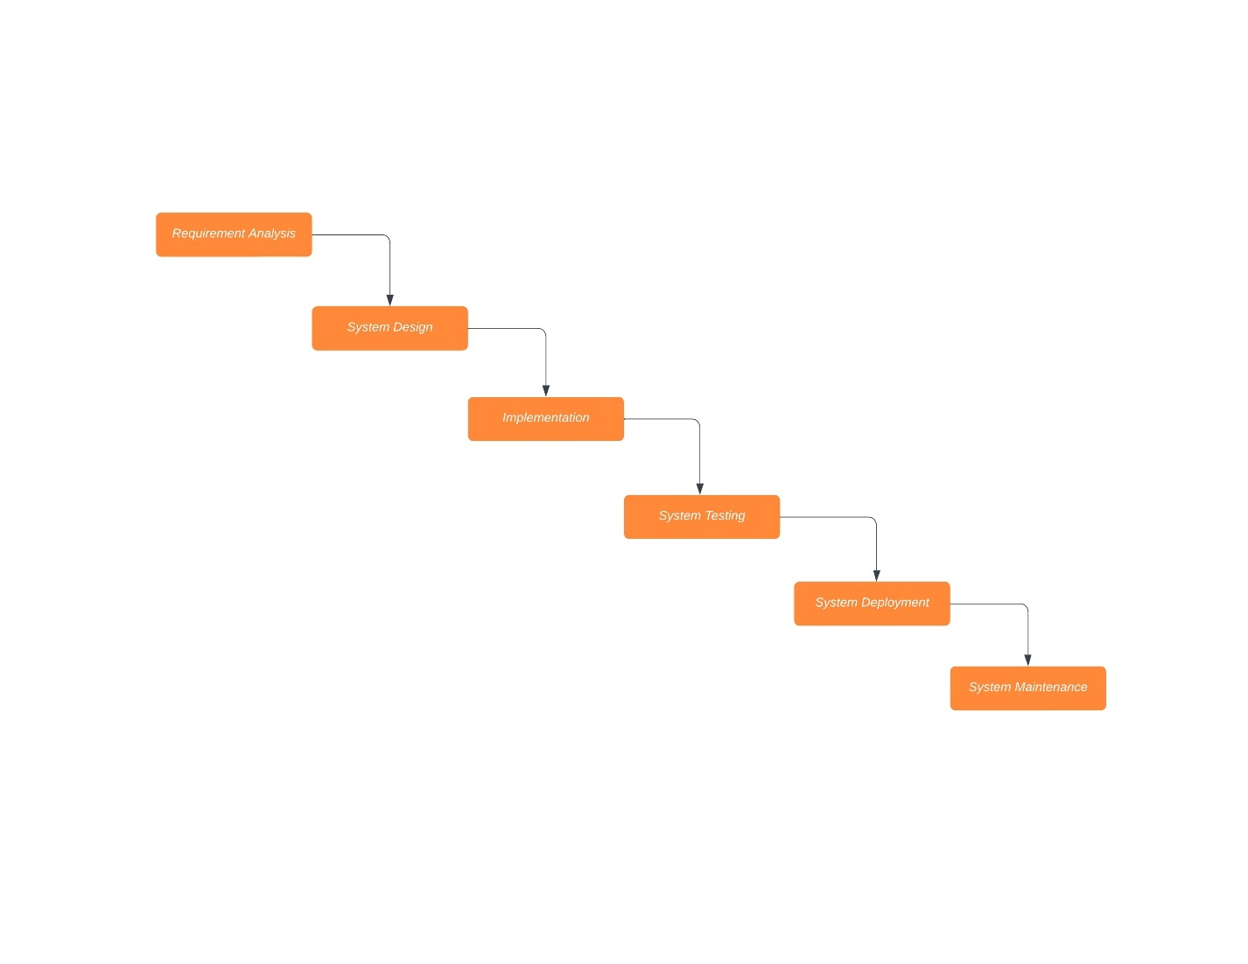

Figure 1.1 Waterfall model

**Analysis**: This phase includes the gathering of all the requirements of the system. For this, some research was done and some useful insights were pointed out so that the requirements, the functions, and the objectives of the system were well known.

**Design**: It includes the study and designing of the requirements gathered in the analysis phase for the system development. Thus, the formed design was then converted into use case-diagram, data modeling -diagram, interface design where each diagram depicted the design in their unique representation.

**Implementation**: This phase includes the implementation of the design done for system development in the previous phase. The features of the system were developed one at a time and then all the features were integrated to form a complete system in the next phase. All the modules were developed using html, CSS and JavaScript for the front end and PHP and SQL for the backend programming.

**Testing**: The main objective of this phase is to see if the system is functioning as intended or not. This phase includes unit testing as well as system testing under various test case scenarios. In unit testing, each unit is tested one by one whereas in system testing the system as a whole is tested.

**Deployment**: In this phase, the product is made live on production environment after all functional and non-functional testing completed.

**Maintenance**: The errors were debugged, and solved then the completed version of the system was delivered to the concerned parties.

* 1. **Report Organization**

This report document is divided into five chapters, one of which is titled "Chapter 1 **Introduction**". The second chapter, "**Background Study and Literature Review**" defines and describes the Background Study and an overview of related and existing systems, as well as their benefits and drawbacks. In contrast, Chapter three "**System Analysis and Design**" discusses System Analysis and Design, which includes Requirement Analysis and Feasibility Analysis. Similarly, Chapter Four "**Implementation and Testing**" defines Implementation, Testing, and Debugging. Finally, in Chapter Five, "**Conclusion and Future Recommendation**" it discusses the Conclusion, Limitations, and Future Enhancement of the System.

# CHAPTER 2

# BACKGROUND STUDY AND LITERATURE REVIEW

**2.1 Background Study**

The rise of online room reservation systems has transformed the way customers search for and book rooms, revolutionizing the hospitality industry. This shift from traditional offline booking methods to online platforms has been driven by the accessibility and extensive information available at users' fingertips. The convenience of booking from anywhere, anytime, has made the process more efficient, eliminating the need for physical visits or phone calls.

In the context of Nepal, there are already several established online room reservation systems, such as Booking.com, Booking Sansar, etc., but these websites are inaccessible and unreliable. The "Homelystay- Online Room Reservation System" offers a user-friendly interface that makes it simple for users to reserve a hotel or room.

Before starting the project, we performed a direct interview with college students, people in the area, and a questionnaire. The results showed that there is a need to work on a project of this nature and that it will be beneficial to both domestic and foreign travelers.

**2.2 Literature Review**

In the preparation of this report, several articles, documents, and projects relevant to online room reservation systems, and other similar topics were reviewed. The following is a brief description of the report's sources:

The distribution of hotel rooms around the world will be accomplished by using the internet reservation system. The market's potential won't be constrained by space or time. Hotels frequently use this technology to assign rooms to visitors. By soliciting consumer participation to share their product evaluation with prospective customers, online customer reviews are used as a promotional strategy. This approach is frequently employed since customers' opinions are more reliable than those of vendors. The objective of the present study is to investigate the role of digital marketing strategies, especially the impact of the online reservation system and online customer review on brand image, trust, and hotel booking decision. [1]

“Airbnb” is more competitive on one particular vector; rather, the “trust” vector was by far the biggest priority for both travelers and hosts. Hotels could be infinitely more inconvenient, expensive, or sterile relative to your typical homestay and it wouldn’t matter. The result of Airbnb creating a platform of trust is not that a homestay is now more trustworthy than a hotel, but rather that the hotel's trust advantage has been neutralized, allowing homestays to compete on new fronts, such as convenience, cost, and environmental considerations. [2]

“OYO Hotels & Homes” have very low starting prices, and the company charges hotel owners a sizeable percentage for reservations made through its website. OYO hopes to grow into a large-scale hotel business, and as of right now, it leases or franchises more than 18,000 premises in 22 nations. The goal of the research is to comprehend the OYO rooms' exponential global growth and how it relates to the company's investments. Analyzing the expanding global demand for reasonably priced hotel services and comprehending the market gap are two important aspects of this study. [3]

“Booking.com”, a renowned online travel agency, offers several advantages on its website. One of its key strengths is its extensive accommodation selection, which includes hotels, guesthouses, apartments, and more, providing users with a diverse range of options worldwide. The platform is known for its competitive pricing, offering attractive rates and exclusive deals to help users find affordable accommodations. User reviews and ratings play a significant role, providing valuable insights from previous guests and aiding in decision-making. The website's intuitive search and booking process streamline the experience, allowing users to easily find and reserve their desired accommodations. Booking.com also supports multiple languages and currencies, making it accessible to a global user base. [4]

“Trip.com”, a popular online travel agency, offers several advantages on its website. With an extensive inventory of accommodations worldwide, including hotels, guesthouses, and apartments, users have a wide range of options to choose from. The website also provides competitive pricing, often featuring discounted rates and exclusive deals. User reviews and ratings are available, offering valuable insights from previous guests to inform decision-making. The convenient search and booking process, multi-language and currency support, and 24/7 customer support further enhance the user experience. [5]

# CHAPTER 3

# SYSTEM ANALYSIS AND DESIGN

**3.1 System Analysis**

System analysis is a process of gathering and interpreting facts, diagnosing problems and the information about the Online Room Reservation System to recommend improvements on the system. It is a problem-solving activity that requires intensive communication between the system users and system developers. It is an important phase of any system development process to specify and examine various software development and deployment methods, including the following:

**3.1.1 Requirement Analysis**

It is important to imagine the layout, design, and all features planned to be incorporated before designing a software, whether it is a website or a mobile app. Furthermore, how users will interact with each page and the behavior of icons, as well as how the system should function. The system's required attributes are a statement that describes a capacity, characteristic, or quality aspect in order for the system to provide value and utility to its users. Developers can begin further technical activities such as system design, development, testing, implementation, and operation once the requirements have been established.

There are functional and non-functional needs for any system that must be considered while determining the system's requirements. The functional requirements are user-visible features, such as create report, login, and signup, that are often initiated by system stakeholders. Non-functional requirements, on the other hand, are those that describe how the system will perform what it is supposed to do. Usability, Reliability & Availability, Performance, Security, and Maintainability are just a few examples.

1. **Functional Requirement**

**Admin**

* Can log into the system.
* Can check and manage the room availability.
* Can manage and record the data.
* Can confirm the booking order.
* Can cancel the order.
* Can manage the staff availability.

**Users**

* Can register/login.
* Can view lists of accommodation in the homepage.
* Can search for rooms based on the criteria such as price, room types.
* Can book the room.
* Can view lists of facilities in the homepage.
* Can contact us through the social media.

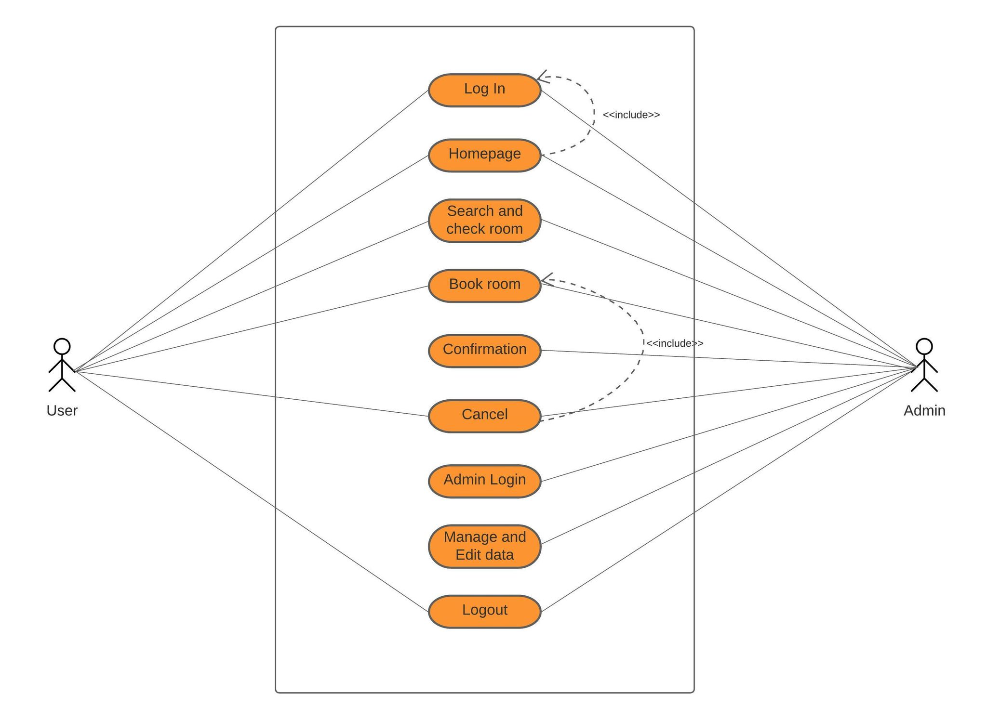

Figure 3.1: Use Case Diagram

**ii. Non-Functional Requirement**

#### 

**a. User Friendly:** User Friendly is self-explanatory. When something is user friendly then it is easy to access and work with it. Homelystay - online room reservation system is user friendly. Person having basic knowledge and skills of computers can also easily use the web application.

**b. Availability:** This system is available to users anytime and anywhere, just need a PC and a dedicated Apache server and the database. Also, the system works in multiple web browsers like (Chrome, Mozilla, Opera and many more)

**c. Reliability:** The system has to be 100% reliable due to the importance of data and the damages that can be caused by incomplete data. The system will run 7 days a week, 24 hours a day.

**d. Maintainability:** The system will be easily maintained by the developer or other authorized trained person and backup for database are available.

**3.1.2 Feasibility Study**

**i. Technical feasibility:**

An examination of resource availability as it relates to the ability to achieve an acceptable system. This assessment determines whether or not the technology required for the proposed system is available. This is involved with identifying the hardware and software that will successfully meet the user's needs. The system's technological requirements include:

**Front-End and Back-End Selection**

**Front end selection**: For front end selection this project has use HTML, CSS,

JavaScript as a front-end tool

**Back-end selection:** This system has used PHP as a backend tool and Apache as a web server whereas MySQL is used as for storing.

**ii. Economic feasibility:**

Most systems bottom line consideration is usually economic rationale. The term economic justification refers to a wide range of issues, including cost-benefit analysis. The cost is analyzed associated with the proposed system, and if it meets the organization's primary goal of profit, the project moves on to the analysis and design phase. The development of an "Homelystay – Online Room Reservation System" does not require a large sum of money to be built and operate. This can be done in a cost-effective manner if properly planned, thus it is feasible.

**iii. Operational feasibility:**

The system is operationally practical since it is simple to use for end users. It simply requires basic understanding of the Windows operating system and be familiar with web browsers.

**iv. Schedule feasibility:**

The most significant aspect in the development of a project is time evaluation. More development time affects machine time, costs, and causes delays in the development of other systems, therefore the time schedule for this project's development is crucial. In a reasonable length of time, a reliable online room reservation system may be created.

To calculate and continually re-examine whether it is possible to complete all amount and scope of work lying ahead, utilizing the given number of resources within required period of time. In this project Gantt Chart is used to represent the Schedule Feasibility.

**Gantt Chart**

The project uses Microsoft Excel to create a Gantt Chart, as seen in the figure and table below.

**Table 3.1: Gantt Chart Table**

|  |  |  |  |
| --- | --- | --- | --- |
| **Activities** | **Start Date** | **End Date** | **Duration** |
| Idea Generation | 25/12/2079 | 30/12/2079 | 5 |
| Proposal Writing and  Presentation | 01/01/2080 | 12/01/2080 | 12 |
| Analysis and Data Collection | 13/01/2080 | 22/01/2080 | 9 |
| System Design | 23/01/2080 | 09/02/2080 | 16 |
| Implementation | 10/02/2080 | 30/02/2080 | 20 |
| Testing and debugging | 31/02/2080 | 16/03/2080 | 18 |
| Documentation | 25/12/2079 | 20/03/2080 | 85 |

**3.1.3 Data Modeling**

The act of generating a visual representation of an entire information system or parts of it in order to express linkages between data points and structures is known as data modeling. For higher-level data models, an ER- Diagram is a good idea. Entity Relationship Diagram

(ERD) is a diagram that shows the relationship between entity sets contained in a database.

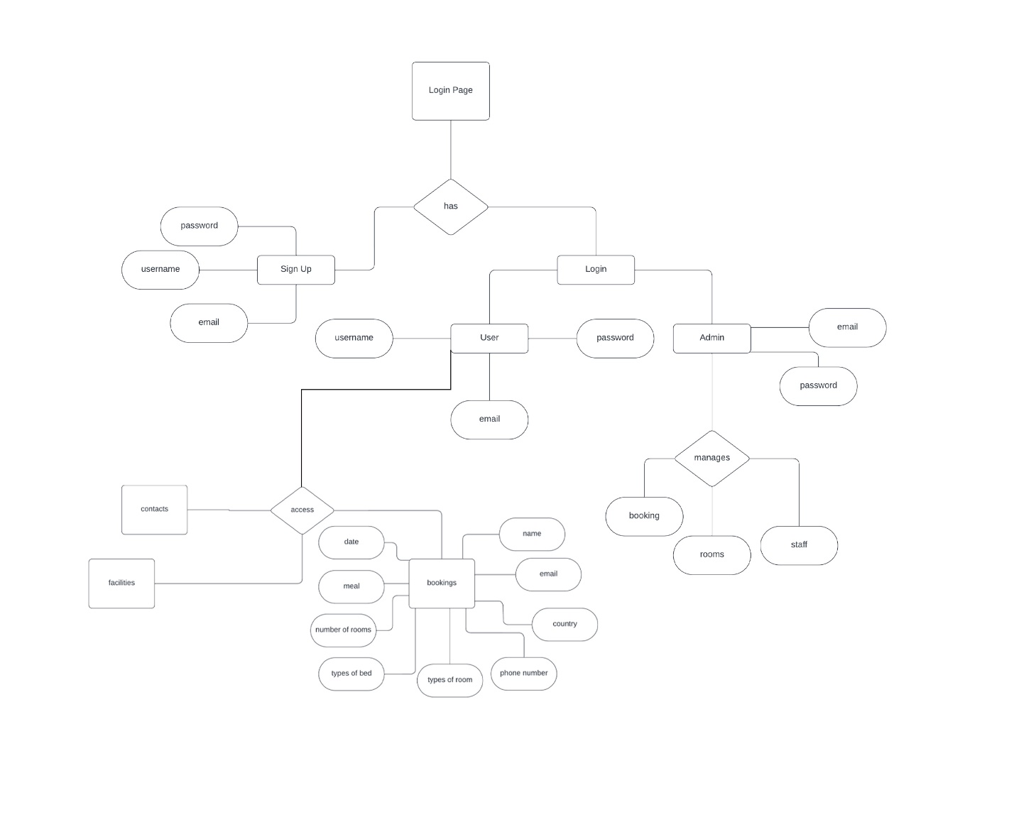

Figure 3.2: ER Diagram

**3.1.4 Process Modeling**

The graphical representation of workflows is Process modeling. Process modeling is defined by a DFD (Data Flow Diagram). A data-flow diagram is a visual representation of data flowing through a system or a process. The DFD also includes information on each entity's outputs and inputs, as well as the process itself.

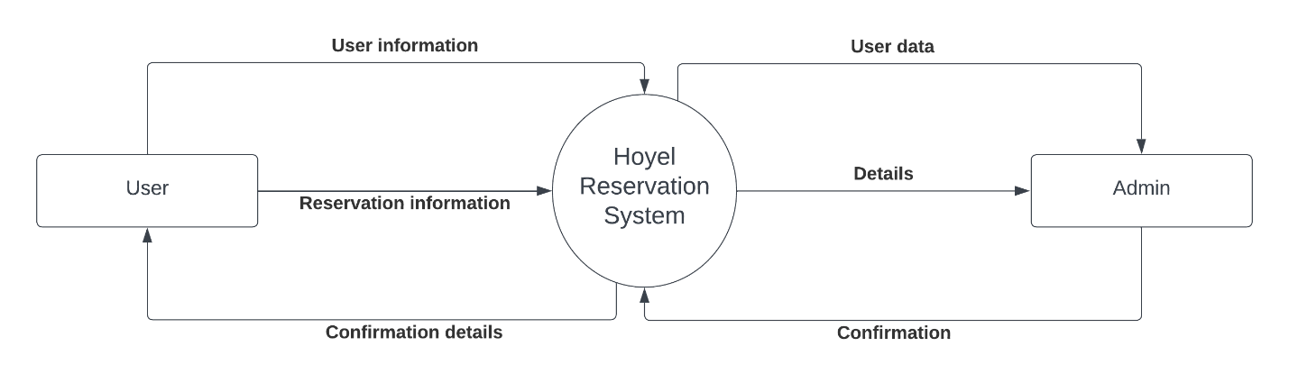

Figure 3.3: Context Level Data Flow Diagram.

**3.1.5 FLOWCHART**

A flowchart is a visual representation of a process, algorithm, or system, using different symbols and arrows to depict the flow of information, data, or steps. It provides a structured and hierarchical representation of a sequence of activities, decisions, or events.

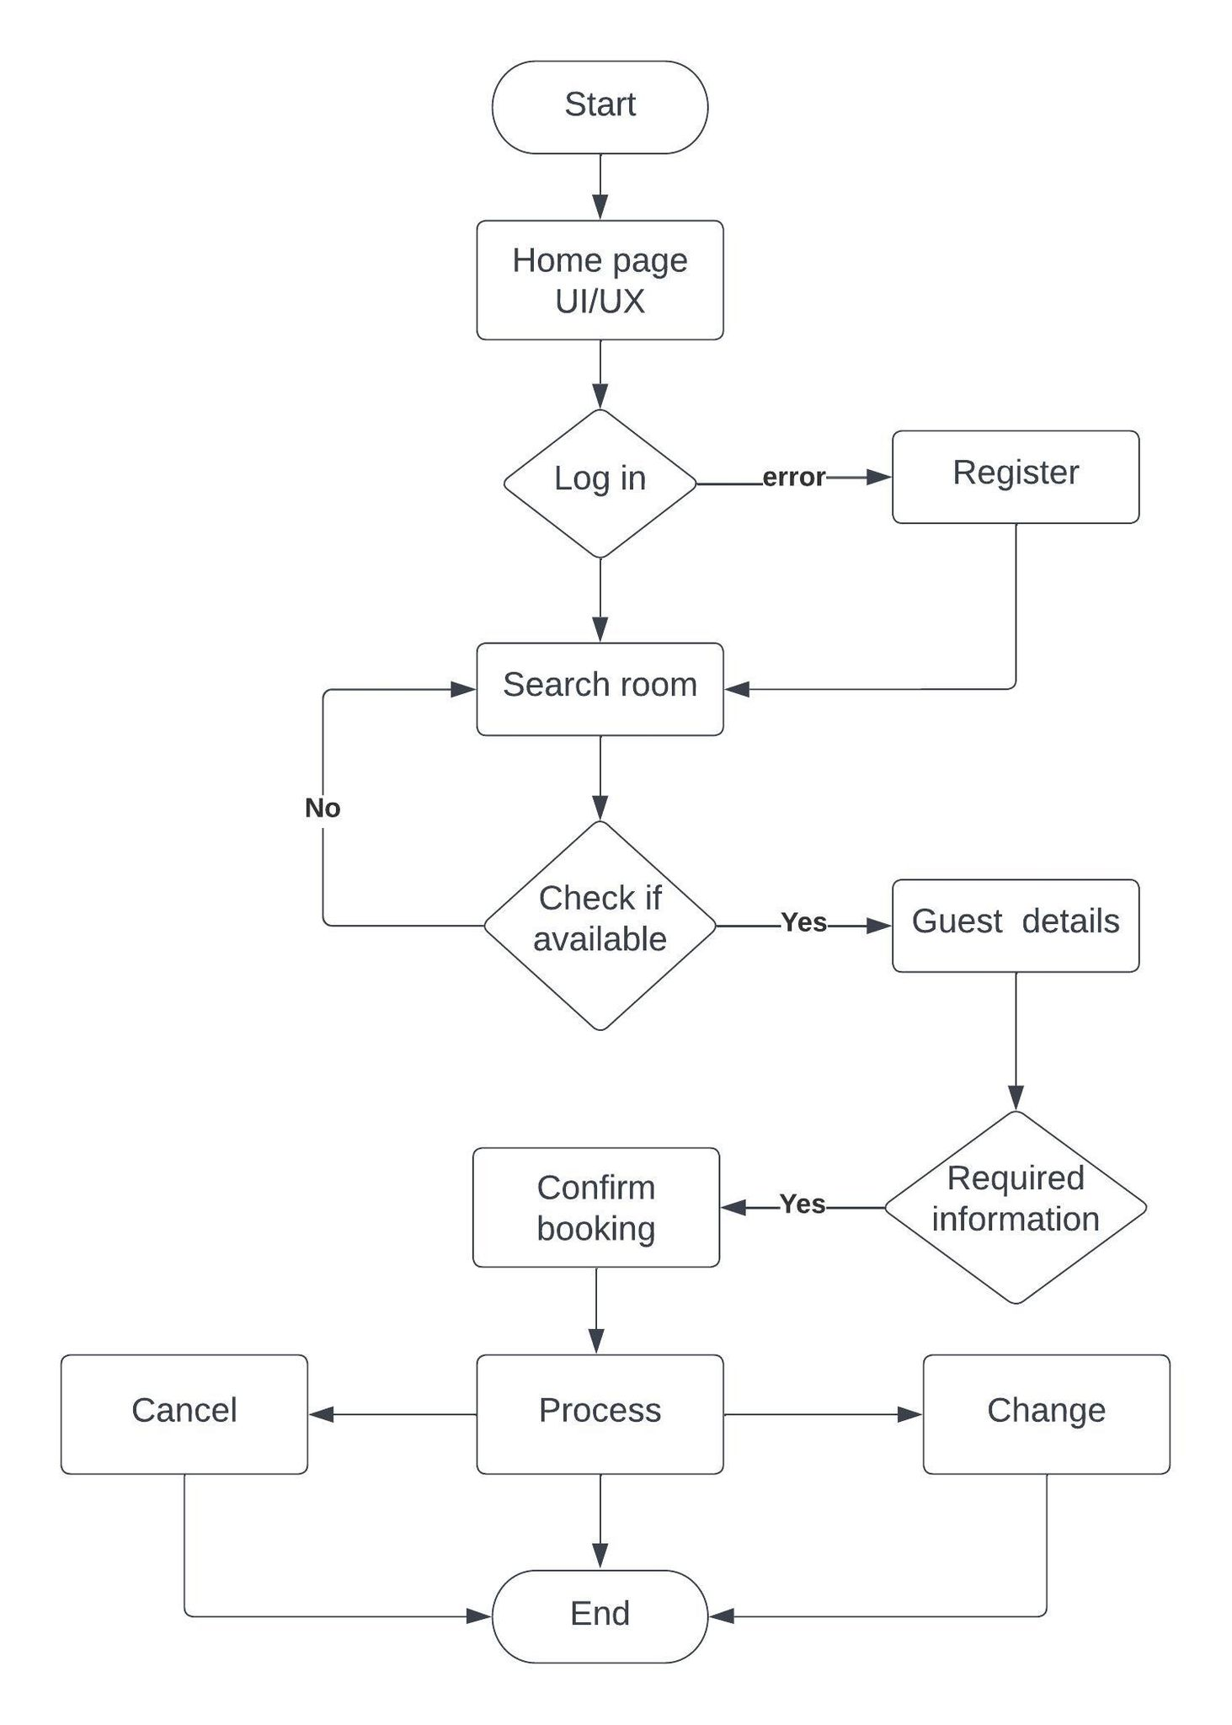

Figure 3.4: Flowchart Diagram

**3.2 System Design**

The process of defining the architecture, product design, modules, interfaces, and data for a system in order to meet specific criteria is known as systems design. It's designed to meet a company's or organization's specific goals and requirements by constructing a well-functioning system.

**3.2.1 Architectural Design**

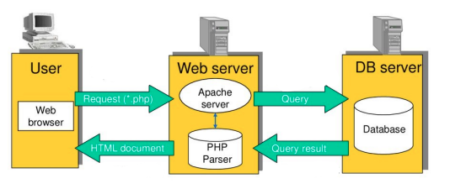

Figure 3.5: Architectural Design

The above diagram shows the connectivity between the client side, application server and database server. The client or customer can access the HTML server or client software. These are connected to the Apache Server. This Apache Server now directly communicates with the database made in MYSQL. All the enquires or data will be retrieved from the database.

**3.2.2 Database Schema Design**

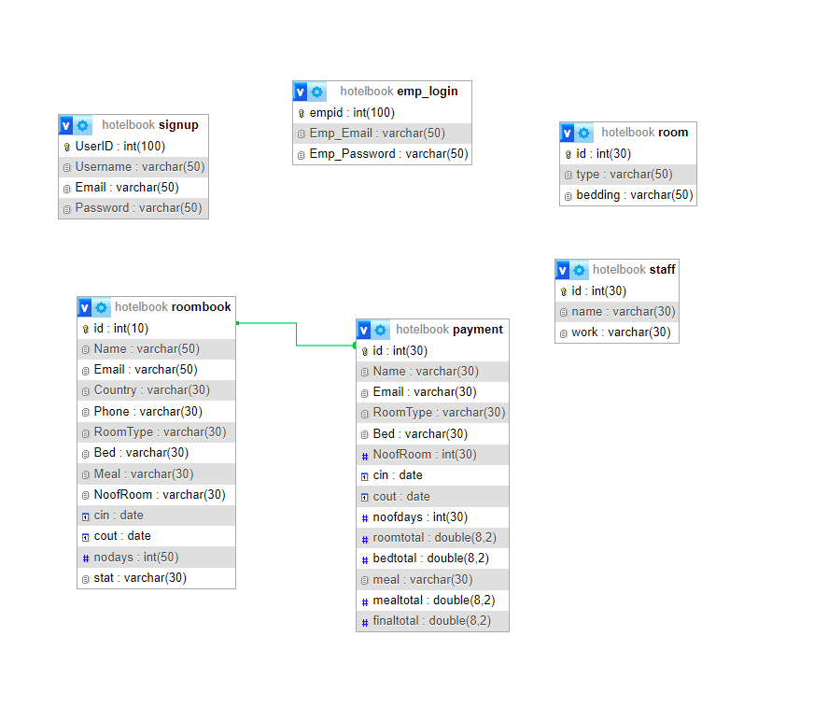

Figure 3.6: Database Schema Design

**3.2.3 Interface Design**

Few users interface design was created before the actual design of the project is implemented to visualize the user interaction with the system as they explore registration, login and homepage. This systems functional Decomposition Diagram, which shows the early design of the web pages, would be closely followed by the user interface design.

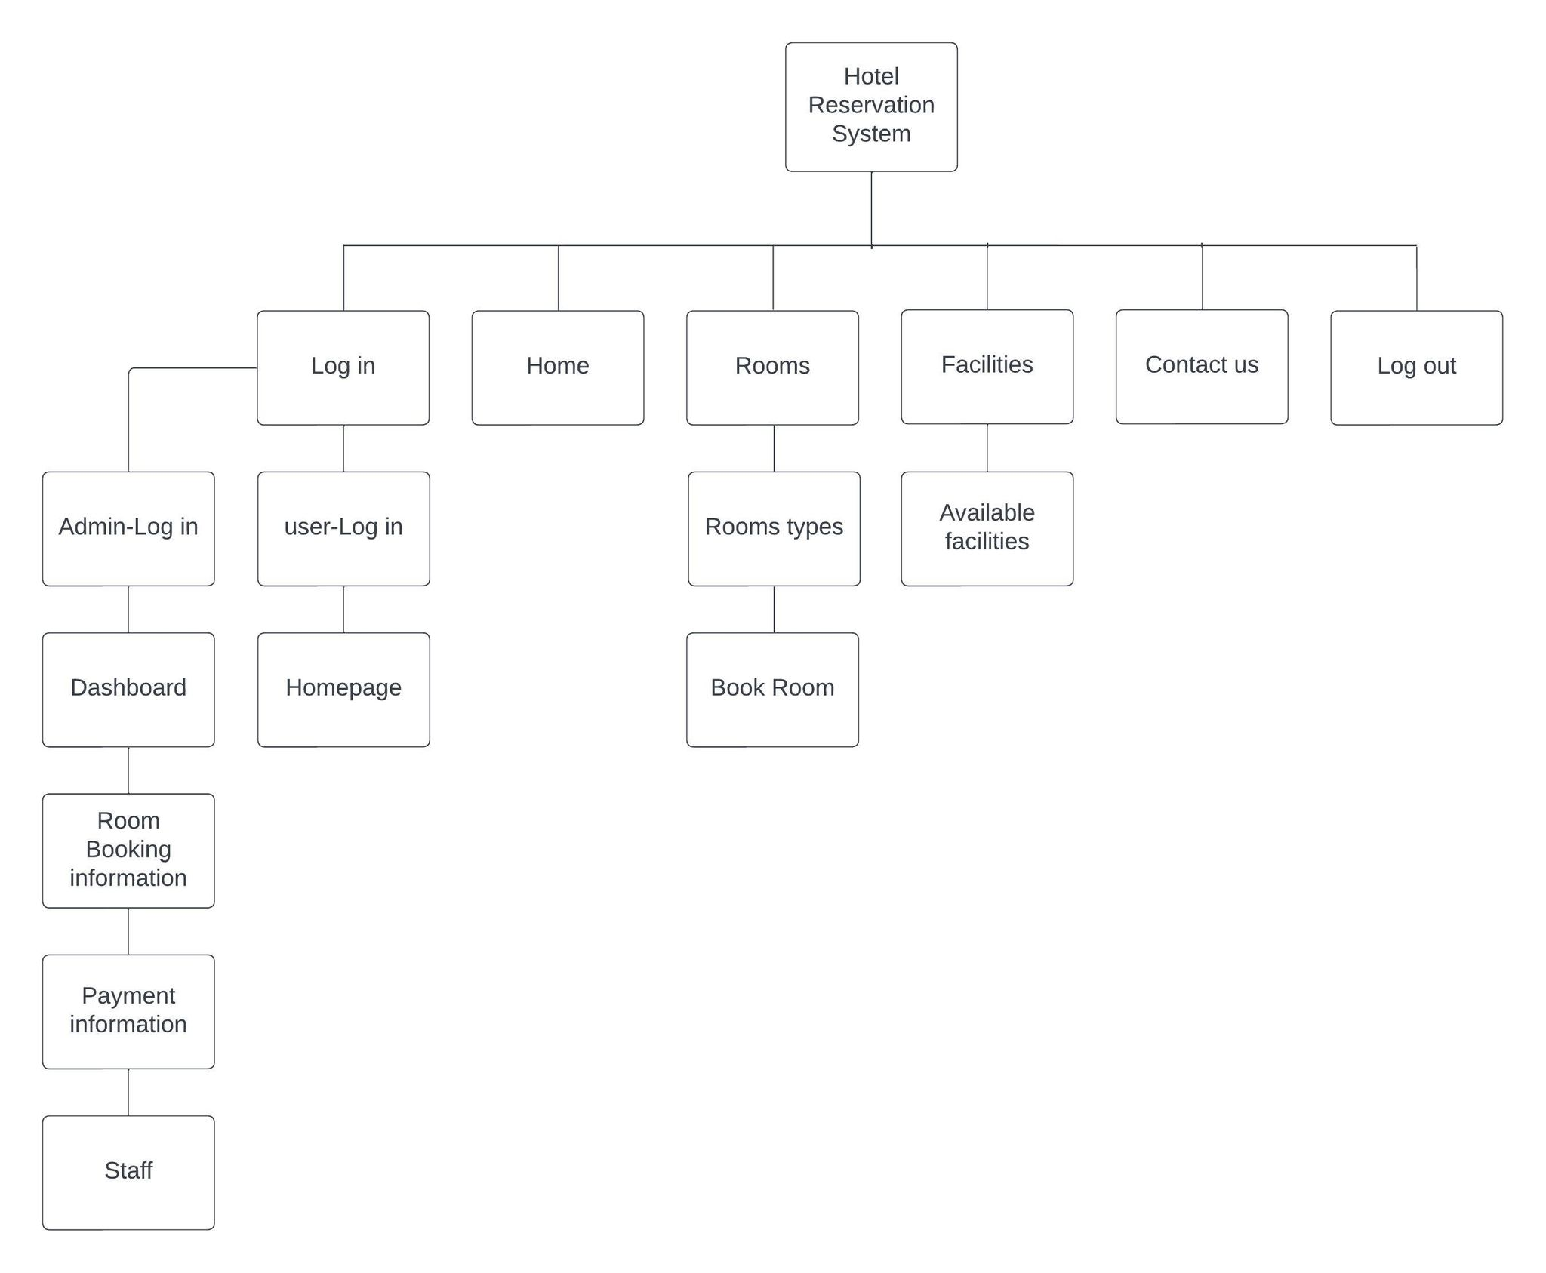

Figure 3.7: Interface Design

**3.2.4 UI Interface**

User Interface is crucial because it serves as the bridge between users and a system or application.

It facilitates seamless interaction, enabling users to navigate through various functionalities and

access the desired features. A user-friendly UI enhances the overall user experience by presenting

information in an intuitive and visually appealing manner.

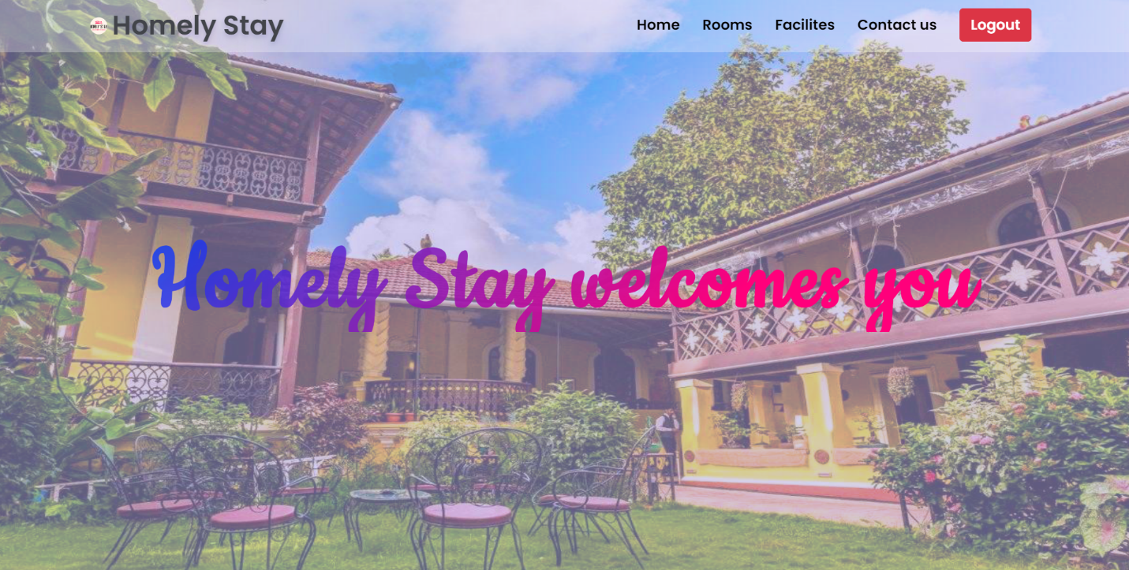

Figure 3.8: UI interface

**3.2.4 Physical DFD**

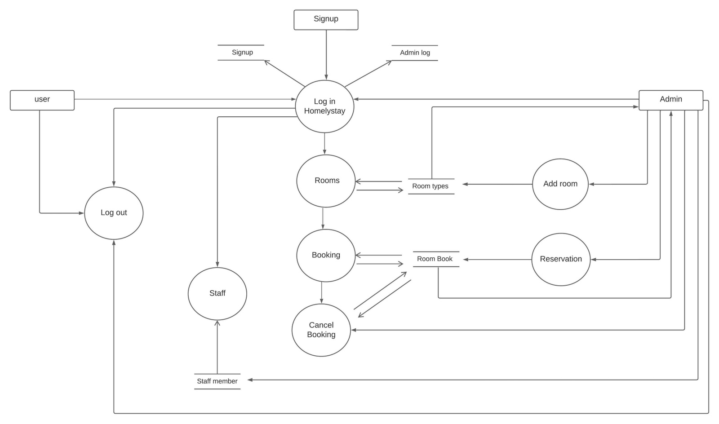

Figure 3.9: Physical DFD

# CHAPTER 4

# IMPLEMENTATION AND TESTING

* 1. **Implementation** 
     1. **Tools Used (CASE tools, Programming languages, Database platforms)**
        1. **Front End Tools**

**HTML**: HTML is used to design the frontend views of this system.

**CSS**: CSS is used for describing the presentation of the front-page including colors, layout, and fonts of the system.

**JavaScript**: JavaScript web framework is one of the best ways to stack backend and frontend frameworks and has been used for the same in the project

* + - 1. **Back End Tool**

**PHP**: The PHP Hypertext Preprocessor (PHP) is a programming language used to create dynamic content that interacts with databases. It has helped to send and get requests and data from and to databases like MySQL in the project and is used for developing web-based software applications.

**MYSQL**: MySQL is an open-source relational database management system (RDBMS). We have used MySQL to store and retrieve data.

## Implementation Details of Modules (Description of procedures/functions)

There are different module descriptions. They are described below:

**Registration Module:** This module is dedicated to register all the bookings from the customers whenever they want. The process of this module performed by the process in which one registers the complete details of the customer who wants to submit the booking.

**Monitoring Module:** This module is dedicated to booking the rooms by searching the preferences. The process of this module is divided into two sub processes in which one searches for rooms and other book the rooms.

**Admin Module:** This module can be accessed by those having admin credentials and are responsible for processing the booking and closing it once the booking is done.

# Testing

Testing is the process of detecting errors. It performs a very critical role for quality assurance and for ensuring the reliability of software. The results of testing are used later on during maintenance also.

## Test Cases for Unit Testing

Unit testing is a software development process in which the smallest testable parts of an application, called units, are individually and independently scrutinized for proper operation. Online Room Reservation System contains different types of individual parts that are tested. Some of the test cases are:

Table 4.2.1.1: Test Case execution for admin login

|  |  |  |  |  |  |  |
| --- | --- | --- | --- | --- | --- | --- |
| **S. N** | **Modul e** | **Test Case** | **Input** | **Expecte d**  **Output** | **Actual Output** | **Remar ks** |
| 1 | Ad min Logi n | 001 | Username: admin Password: admin | Successf ul  Login | Successfu l  Login | Pass |
| 002 | Username: admin Password: pass | Not Logge d in | Not Logged in | Pass |

Table 4.2.1.2: Test Case execution for user signup

|  |  |  |  |  |  |  |
| --- | --- | --- | --- | --- | --- | --- |
| S. N | Modul e | Test Case | Input | Expected Output | Actual Output | Remark s |
| 1 | User Sign up | 001 | Entering all  user’s  required field | Successful Addition of user | Success ful Additio n of user | Pass |
| 002 | Leaving one or more required field empty | Show error in empty field | Show error in empty field | Pass |

Table 4.2.1.3: Test Case execution for user login

|  |  |  |  |  |  |  |
| --- | --- | --- | --- | --- | --- | --- |
| **S. N** | **Module** | **Test Case** | **Input** | **Expected Output** | **Actual Output** | **Remarks** |
| 1 | Use r Lo  gin | 001 | College Id: 9841  Passwor  d: | Successful Login | Successful Login | Pass |
|  |  |  | 123 |  |  |  |
| 2 |  | 002 | College | Not | Not | Pass |
|  |  | Id: | Logged in | Logged |  |
|  |  | 98342 |  | in |  |
|  |  | Passwor |  |  |  |
|  |  | d: sudesh |  |  |  |

Table 4.2.1.4: Test Case execution for Room Booking

|  |  |  |  |  |
| --- | --- | --- | --- | --- |
| S. N | Test Case | Expected Output | Actual Output | Remarks |
| 1 | Click on Book button | Display booking form | Display booking form | Pass |
| 2 | Fill all the details | All the forms to be filled | All the forms are filled | Pass |
| 3 | Click on book action | Booking is edited in database | Booking is edited in database | Pass |

Table 4.2.1.5: Test Case execution for Room Addition

|  |  |  |  |  |
| --- | --- | --- | --- | --- |
| S. N | Test Case | Expected Output | Actual Output | Remarks |
| 1 | Click on Add button | Display Add Room list addition form | Display Add room option | Pass |
| 2 | Click on Submit button | Room is added in database | Room is added in database | Pass |
| 3 | Click on Edit action | Room is edited in database | Room is edited in database | Pass |
| 4 | Select Delete action | Room is deleted from database | Room is deleted from database | Pass |

Table 4.2.1.6: Test Case execution for Staff Addition

|  |  |  |  |  |
| --- | --- | --- | --- | --- |
| S. N | Test Case | Expected Output | Actual Output | Remarks |
| 1 | Click on Add button | Display Add Staff list addition form | Display Add Staff option | Pass |
| 2 | Click on Submit button | Staff is added in database | Staff is added in database | Pass |
| 3 | Click on Edit action | Staff is edited in database | Staff is edited in database | Pass |
| 4 | Select Delete action | Staff is deleted from database | Staff is deleted from database | Pass |

### Test case design for system testing

System testing is used to examine how a system responds to specified requirements. The components that make up this system must be verified in order to see if they perform as planned. The test is considered to be successful if the actual result and the expected output are equal, else it is said to be failed.

Table 4.2.2.1: Test case design for system testing

|  |  |  |  |
| --- | --- | --- | --- |
| S. N | Module | Input | Expected Output |
| 1 | Admin login | Username: admin Password: admin | Successful Login |
| Username: admin Password: 1234 | Not logged in |
| 2 | User signup | Entering valid user details. | Successfully added as a user |
| Leaving one or more required  field empty | Show error in empty field |
| 3 | User login | username: saros  Password: 123 | Successful Login |
|  |  | username: 123  Password: 123123 | Not logged in |
| 4 | Booking Room | Entering all required field | Successfully Room booked |
|  |  | Leaving one or more required  field empty | Show error in empty field |
| 5 | Editing Booking Details | Re-entering all required field | Successfully Room booking information edited |
|  |  | Leaving one or more required  field empty | Show error in empty field |
| 6 | Adding Room | Entering all required fields | Successfully added room |
|  |  | Leaving one or more required  field empty | Show error in empty field |
| 7 | Adding Staff | Entering all required fields | Successfully added room |
|  |  | Leaving one or more required  field empty | Show error in empty field |

### Test case execution for system testing

In the preceding section listed the different test case that must proceed for system testing which defines an expected outcome. The following cases generate the actual output of the components which is compared with the expected output to evaluate pass and fail remark on the basic of the input.

Table 4.2.3.1: Test case execution for system testing

|  |  |  |  |  |  |  |
| --- | --- | --- | --- | --- | --- | --- |
| S. N | Modu le | Test case | Input | Expected Output | Actu al Outp ut | Remar ks |
| 1 | Admin login | 001 | userna me: admin Passw ord:  admin | Successful Login | Successful Login | Pass |

|  |  |  |  |  |  |  |
| --- | --- | --- | --- | --- | --- | --- |
|  |  | 002 | Usern ame: passdj Passw ord: admin | Not logged in | Not logged in | Pass |
| 2 | Users signup | 001 | Entering valid users details. | Successfully added a user | Successf ully added a user | Pass |
| 002 | Leaving one or more required  field empty | Show error in empty field | Show error in empty field | Pass |
| 3 | User login | 001 | Username: saros  Passw ord:  123 | Successful Login | Successful Login | Pass |
| 002 | Usern ame:  98435  0  Passw | Not logged in | Not logged in | Pass |

|  |  |  |  |  |  |  |
| --- | --- | --- | --- | --- | --- | --- |
|  |  |  | ord: 1295 |  |  |  |
| 4 | Booking a room | 001 | Entering all required field | Successfully booked room | Successf ully booked room | Pass |
| 002 | Leaving one or more required  field empty | Show error in empty field | Show error in empty field | Pass |
| 5 | Adding room | 001 | Entering all required field | Successfully added room | Successful ly added  room | Pass |
| 002 | Leaving one or more required  field empty | Show error in empty field | Show error in empty field | Pass |
| 6 | Adding staff | 001 | Entering all the required fields | Successfully added staff | Successful  ly added  staff | Pass |

|  |  |  |  |  |  |  |
| --- | --- | --- | --- | --- | --- | --- |
|  |  | 002 | Leaving one or more required  field empty | Show error in empty field | Show error in empty field | Pass |
| 6 | Editing the details | 001 | Reentering the form | Filling the form | Editing the datas in the database | Pass |
|  |  | 002 | Not filling the require requirements | Show error in the edit section | Datas not been edited in the database | Pass |

# CHAPTER 5

# CONCLUSION AND FUTURE RECOMMENDATIONS

**5.1 Lesson Learnt / Outcome**

There were numerous times during the construction of this application when the author felt that something more should be included; however, owing to a lack of enhancement and excellence in the programming language, there may be certain loopholes that may be fixed once the authors obtain more experience to learn about and experiment with this technology. Because this is the author's first project, everything is brand new. Because the authors had a deadline to submit our paper, they also learned about time management.

**5.2 Conclusion**

In conclusion, the implementation of the online room reservation system has brought numerous benefits to the hotel industry. The primary motive of this system is to provide convenience, accessibility, and efficiency in the booking process for both customers and hosts. The system aims to streamline the entire reservation process by leveraging technology and the internet, eliminating the need for customers to visit or contact hotels directly to make reservations.

By offering an online platform, users can easily browse through a wide range of rooms, check availability, compare prices, and make bookings at their convenience, from anywhere and at any time. This eliminates the limitations of traditional booking methods and allows customers to make informed decisions based on detailed information and reviews.

The web application was ultimately tested after development, and the results were reviewed. Following testing, the benefits of the software were addressed, as were ideas for potential future improvements.

* 1. **Future Recommendation**

In considering future recommendations for the Homelystay - online room reservation system, several key areas can be addressed to further enhance its effectiveness and adaptability. With the increasing use of smartphones and tablets, it is crucial to optimize the system for mobile devices. Developing a responsive and user-friendly mobile application or a mobile-responsive website will enable users to easily access and navigate the reservation system, leading to a seamless booking experience on any device. The system might benefit from adding chatbot capability to enhance customer service and support. Chatbots that are powered by AI can answer simple questions, give prompt responses, and help with booking-related issues, providing round-the-clock availability and quicker response times. As technology advances, the importance of cybersecurity cannot be overstated. Continuously invest in robust security measures to safeguard customer data, protect against potential breaches, and ensure secure transactions throughout the reservation process.

In order to find the user and hotel address, we could also use the real-time GPS tracker.

# REFERENCES

[1] Faliha, Nurul, et al. "Online Reservation System and Online Customer Review: Its Impact on Brand Image, Trust and Hotel Booking Decision." *International Journal of Economics, Business and Accounting Research (IJEBAR)* 5.4 (2021).

[2] Thompson, Ben (July 1, 2015). ["Airbnb and the Internet Revolution"](https://stratechery.com/2015/airbnb-and-the-internet-revolution/). Stratechery by Ben Thompson. [Archived](https://web.archive.org/web/20230306110642/https:/stratechery.com/2015/airbnb-and-the-internet-revolution/) from the original on March 6, 2023. Retrieved May 11, 2023.

[3] Guruprasad, M., Vijay Tandon, Chahat Mishra et al., 2019. “Progress and Performance of OYO Rooms- A Research Based Case Study”, International Journal of Current Research, 11, (08), 6688-6693.

[4] Lightfoot, Ashley (27 September 2022). "How Booking.com Became Travel's Biggest Brand". Latana.

[5] O'Neill, Sean (19 November 2017). "Ctrip Relaunches Trip.com as Its English Language Travel Agency Brand". Skift.

# APPENDIX

Figure: User Login

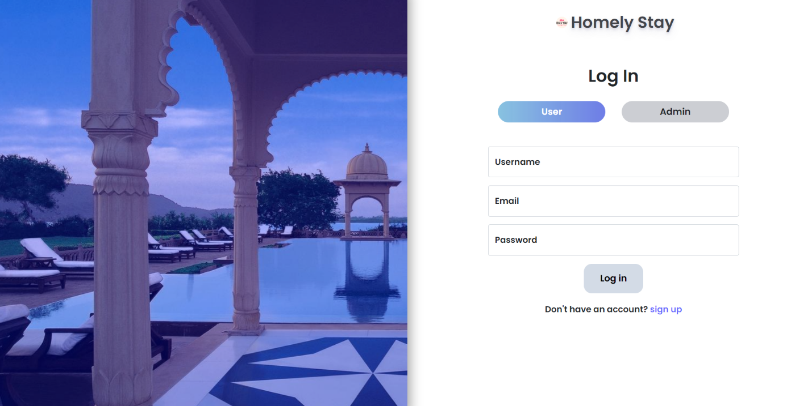

Figure: User Sign Up

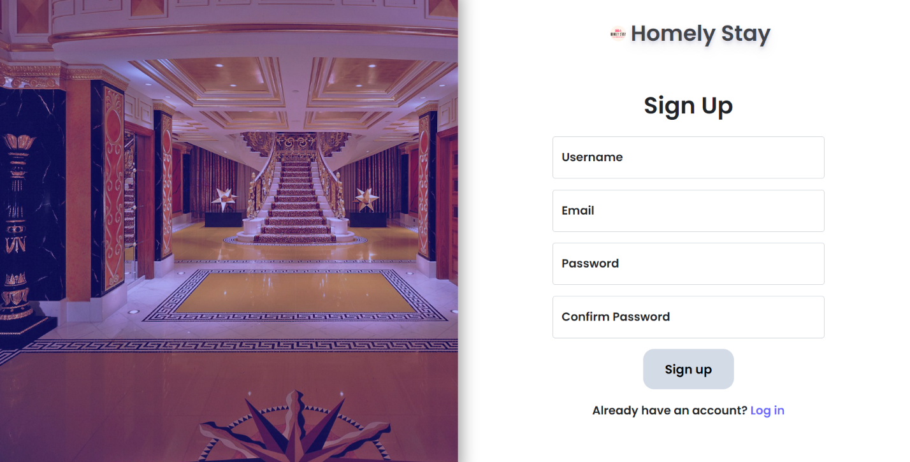

Figure: Admin Login

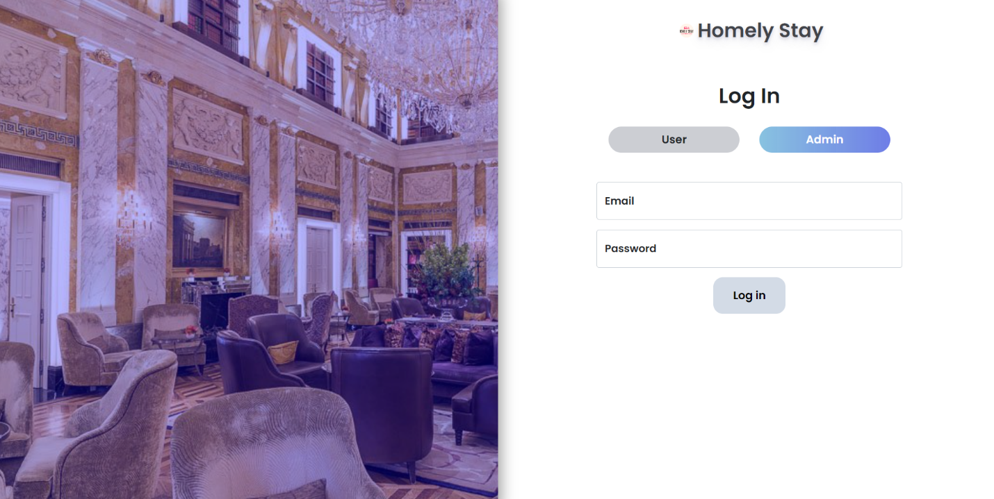

Figure: Homepage

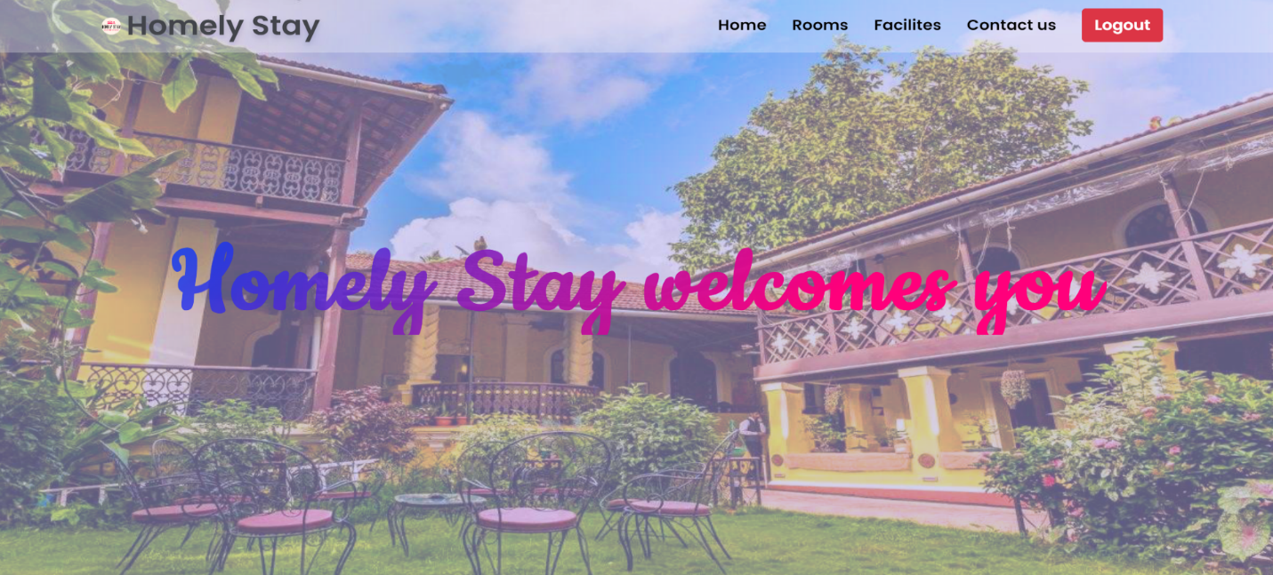

Figure: Rooms Section

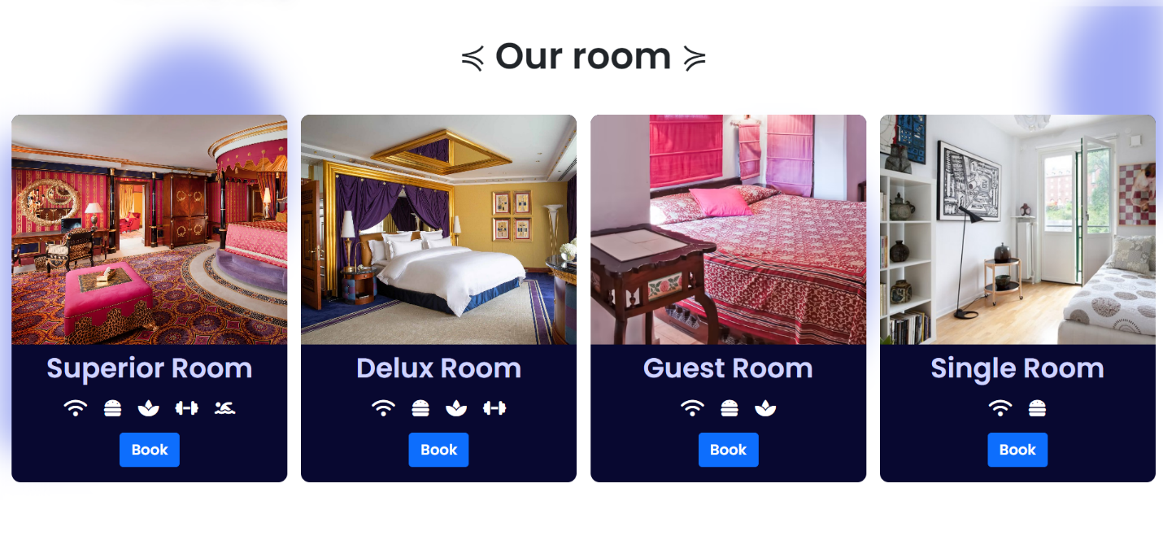

Figure: Facilities Section

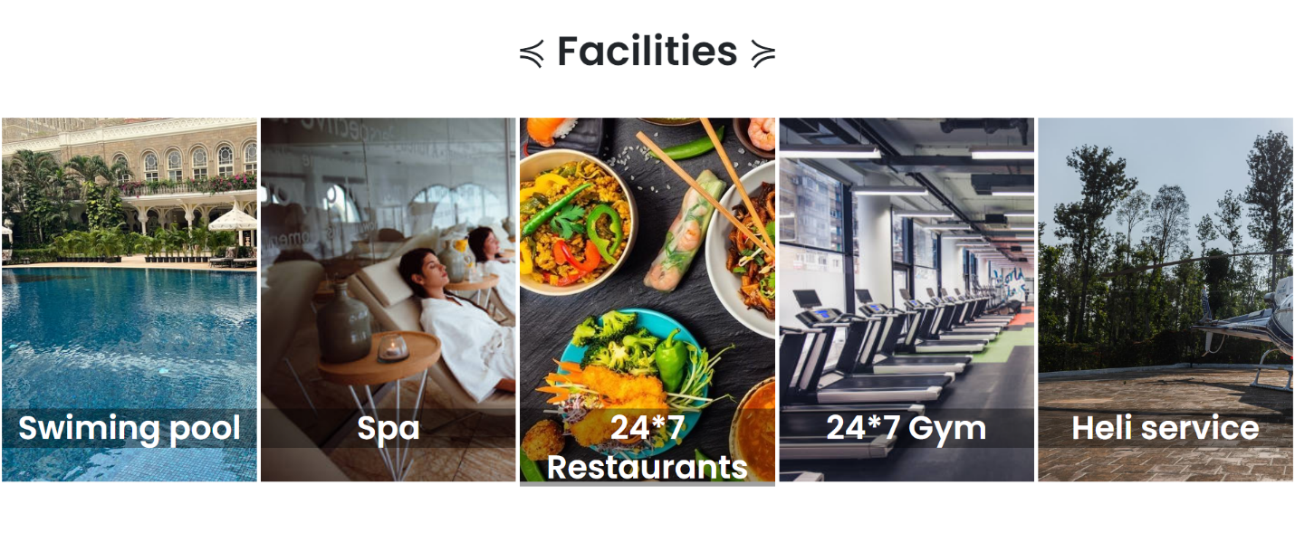

Figure: Admin Dashboard

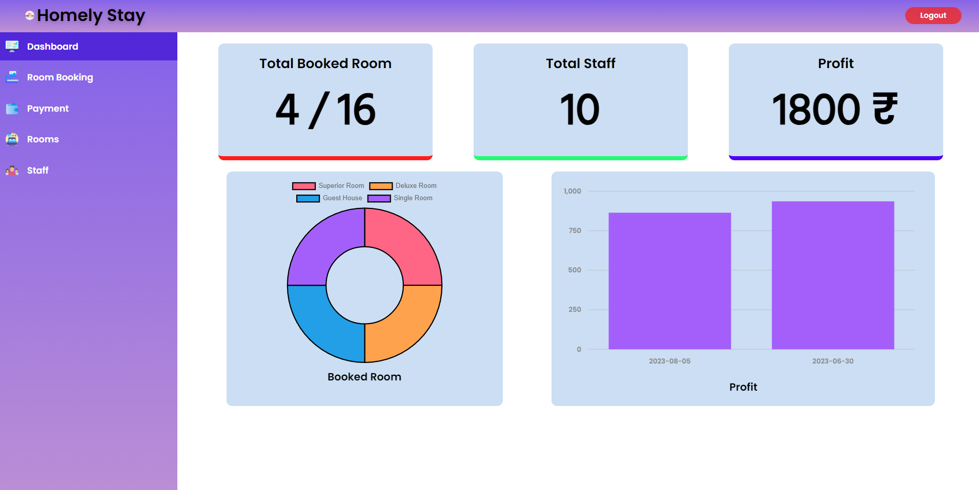

Figure: Admin Room Booking Check

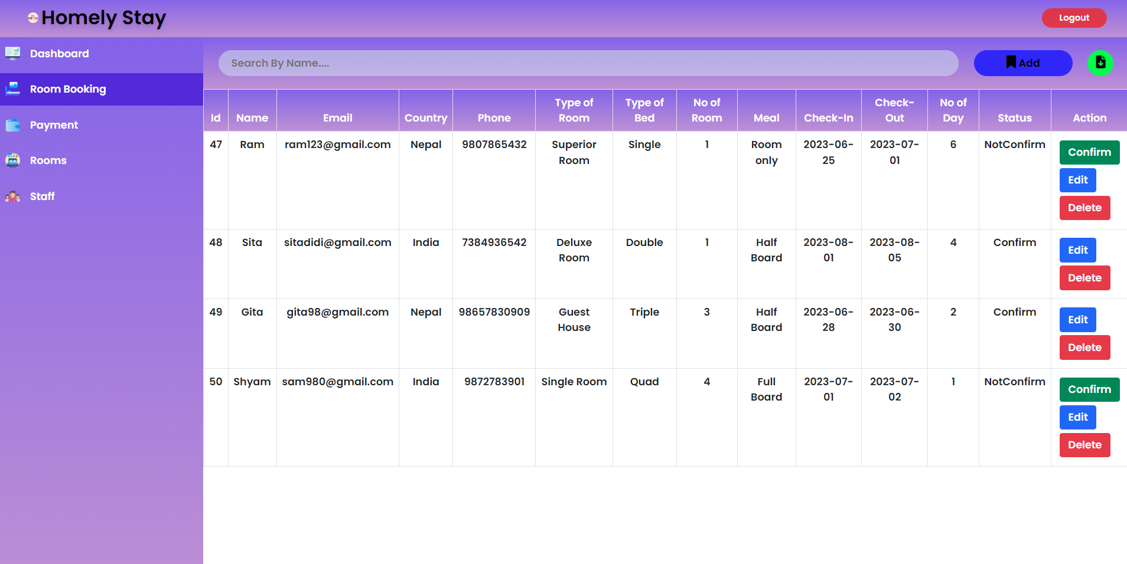

Figure: Admin Payment Check

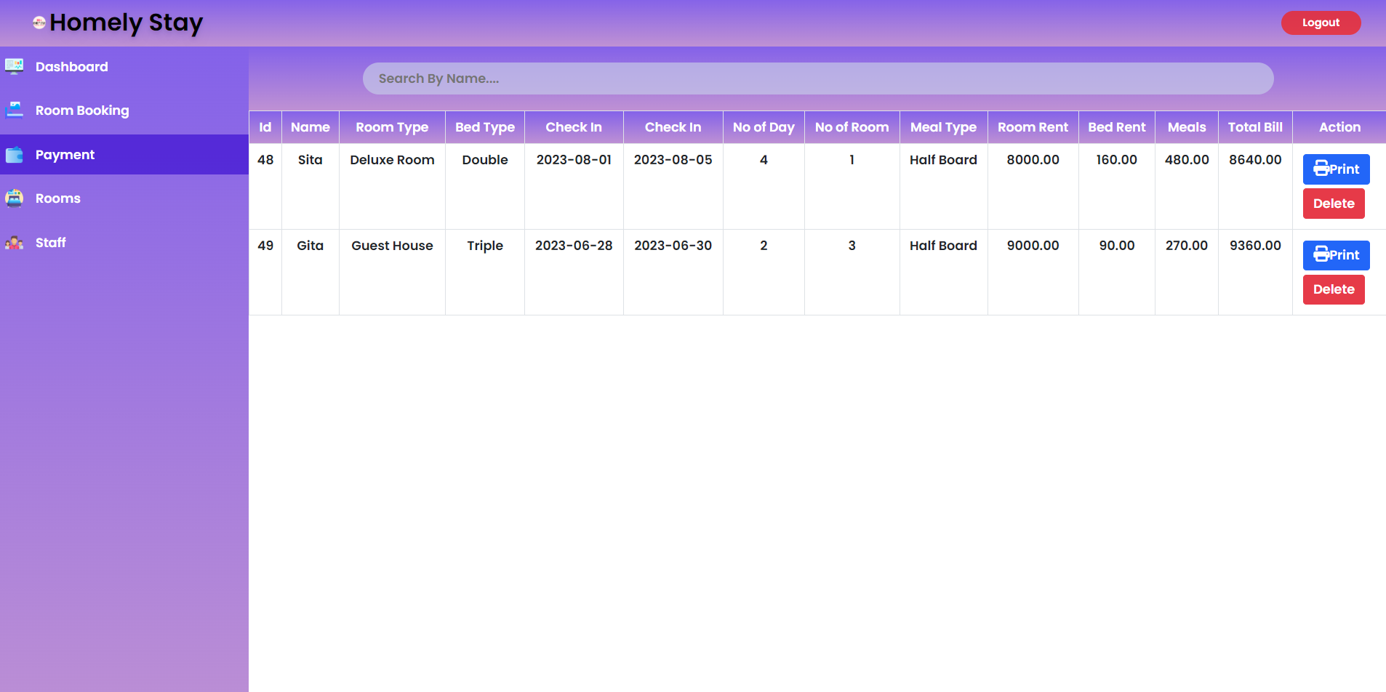

Figure: Admin Room

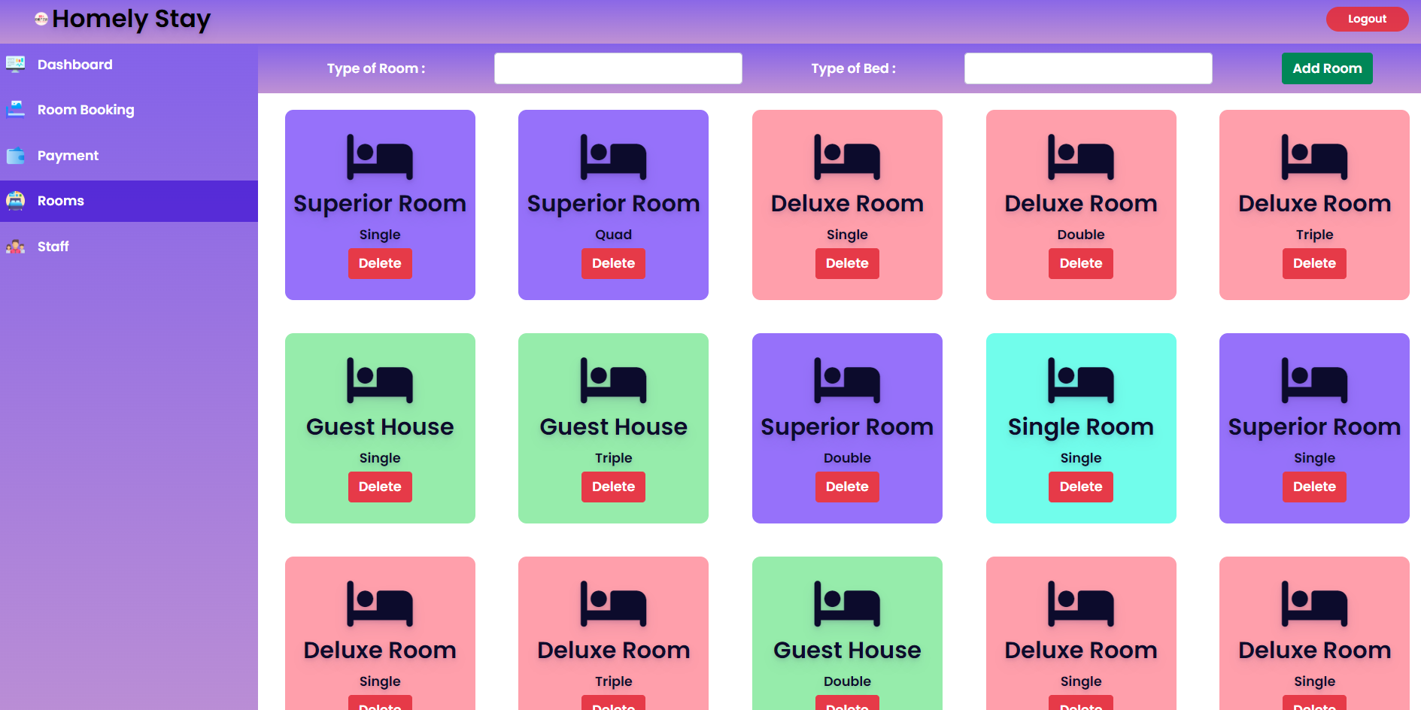

Figure: Admin Staff

